Chapter 1: Brushing of the dust: my python refresher journey
Today, I officially started my journey with a Python refresher, and I have to admit, it felt a bit like visiting an old friend after a long time apart. I remembered enough to feel familiar, but there were gaps I knew I needed to fill if I wanted to walk confidently into the world of Machine Learning.
The first stop was a simple introduction and information session. It reminded me why Python is so powerful. It’s easy to read, easy to write, and, most importantly, flexible. Whether it’s building websites, analyzing scientific data, or training AI models, Python can do it all. I learned that the language was created by Guido van Rossum in the late 1980s with a philosophy of code readability and simplicity (van Rossum, 1991). That’s why even complex programs often feel intuitive in Python.
Next, I stepped into the world of Python and Jupyter. Jupyter notebooks are like magical interactive documents where I can write and run code in chunks. I realized how powerful they are for experimenting with ideas quickly, without needing to create complete programs. It’s like having a lab bench where you can test small reactions before setting up a full experiment. Researchers at UC Berkeley and the broader scientific community have driven Jupyter’s popularity because it blends coding with storytelling and visualization so naturally (Kluyver et al., 2016).
After getting my bearings in Jupyter, I dove into an introduction to data types. Python organizes information into different types. Numbers can be integers or floats; text is handled as strings; truth values are booleans. Knowing the type of data you’re working with matters because it defines what operations you can perform. For example, you can add two numbers together, but if you try to add a number to a string without converting one of them, Python will throw an error. It felt a lot like sorting tools in a toolbox — a hammer works for nails, but not for screws. In machine learning, choosing the right type of data matters just as much.
From there, I entered the world of lists and indexing. A list in Python is like a magical row of boxes where you can store anything: numbers, strings, even other lists. Lists are ordered, so each item has a specific spot you can refer to. I practiced creating a list of my favorite fruits, then picking out the second fruit just by using an index. Python starts counting at zero, which still feels strange to me, but it’s a common tradition in computer science dating back to early programming languages like C (Kernighan & Ritchie, 1978).
Playing with lists naturally led me to tuples and dictionaries. A tuple is just like a list but immutable, meaning once you create it, you can’t change it. It’s great for data you want to protect, like GPS coordinates or fixed settings. Dictionaries are another incredible tool. They pair keys with values, like a real-world dictionary where a word maps to its definition. I made a little dictionary of country codes: “US” mapped to “United States,” “FR” mapped to “France.” In machine learning, dictionaries are essential because we often need fast, flexible ways to retrieve data based on a label rather than a position.

As the sun moved across the sky, I entered one of my favorite topics: writing functions in Python. Functions are reusable blocks of code that do a specific task. I thought of them like recipes. Once you write down how to make a cake, you can bake it again anytime without reinventing it. Functions make programs cleaner, shorter, and easier to understand. For instance, I wrote a little function to convert temperatures from Celsius to Fahrenheit, and it felt satisfying to call it whenever I needed it instead of typing the formula each time. Functions also support something called modularity — a principle that’s been emphasized in software engineering for decades (Parnas, 1972).
But programming isn’t just about writing straight-line recipes. Real programs need to make decisions and repeat tasks. That’s where loops and conditionals come in. Conditionals are like forks in the road: if something is true, go one way; if not, go another. I created simple conditionals to check if a number was positive, negative, or zero. Loops let programs repeat tasks. I wrote a loop to print all numbers from 1 to 5 and smiled when the output scrolled down the screen. Loops come in two flavors: for loops, where you know how many times you want to repeat something, and while loops, where you keep going until a condition is no longer true. It struck me how loops and conditionals mirror real-life decision-making and repetition.
Later, I was introduced to NumPy — short for Numerical Python. It’s a special library that supercharges Python’s math abilities. Instead of slow loops, NumPy uses optimized C code under the hood to crunch large arrays of numbers incredibly fast. It reminded me of switching from riding a bicycle to flying a jet. I practiced creating arrays, which are like turbocharged lists that support complex mathematical operations. For example, I could multiply two arrays together element-by-element with just a simple command. NumPy’s power is why almost every machine learning and data science project uses it today (Oliphant, 2006).
As night fell, I finished with an introduction to pandas. Pandas is a library for working with structured data, like tables you’d see in Excel or a database. It introduced two new magical objects: Series and DataFrames. A Series is like a fancy list with labels, and a DataFrame is like a full spreadsheet — rows and columns, labels and all. I loaded a small CSV file and could instantly sort, filter, and group data with just a few lines of code. I could see why Wes McKinney created pandas: to make it easier for researchers and analysts to wrangle messy real-world data into something meaningful (McKinney, 2012).
Looking back on the day, I realized this Python refresher was much more than just reviewing syntax. It was about rebuilding the way I think about problems. Functions for organization, loops for repetition, conditionals for decisions, lists and dictionaries for storing data, NumPy for high-speed computation, and pandas for sophisticated data handling — each tool fits into a bigger picture of solving real-world problems efficiently and effectively.
As I closed my notebook and stretched my tired fingers, I felt a quiet pride. Today wasn’t about writing complex AI algorithms. It was about laying bricks, one at a time, building a foundation strong enough to hold the weight of everything that will come next.
Next, I’ll step into the deeper world of Machine Learning itself — but today, I sharpened my tools. And that makes all the difference.

References

Kernighan, B. W., & Ritchie, D. M. (1978). The C Programming Language. Prentice-Hall.
Kluyver, T., Ragan-Kelley, B., Pérez, F., Granger, B., Bussonnier, M., Frederic, J., … & Willing, C. (2016). Jupyter Notebooks – a publishing format for reproducible computational workflows. In Positioning and Power in Academic Publishing: Players, Agents and Agendas (pp. 87–90). IOS Press.
McKinney, W. (2012). Python for Data Analysis: Data Wrangling with Pandas, NumPy, and IPython. O’Reilly Media.
Oliphant, T. E. (2006). A guide to NumPy. Trelgol Publishing.
Parnas, D. L. (1972). On the criteria to be used in decomposing systems into modules. Communications of the ACM, 15(12), 1053–1058. https://doi.org/10.1145/361598.361623
van Rossum, G. (1991). Python Reference Manual. Centrum voor Wiskunde en Informatica (CWI), Amsterdam.
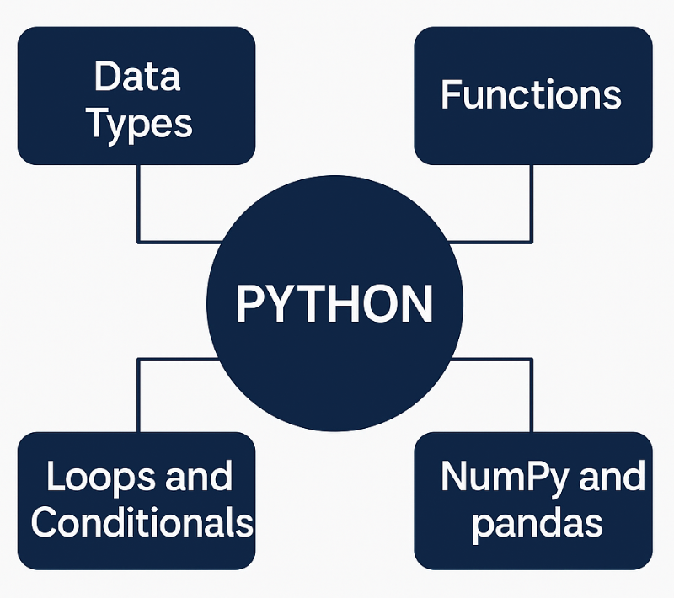
Figure 1.1: Essential Python Concepts for Machine Learning Foundations
This diagram captures the core topics revisited in Chapter 1 during the Python refresher. At the center, Python is presented as the foundational programming language. Branching from it are four critical concepts: Data Types, representing the classification of information like numbers and text; Functions, emphasizing reusable code structures for modular programming; Loops and Conditionals, focusing on decision-making and repeated actions within code; and NumPy and pandas, illustrating essential libraries for numerical computation and data manipulation in scientific and machine learning workflows.

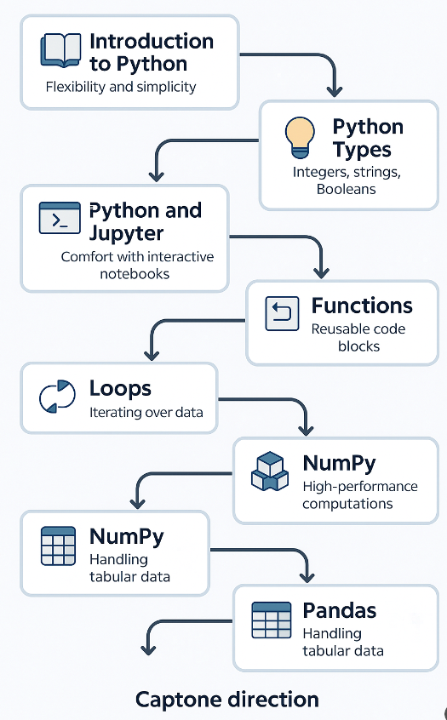
Figure 1.2: Essential Python Concepts for Machine Learning Foundations
This flowchart illustrates the structured journey of refreshing Python fundamentals, critical for transitioning into machine learning. It begins with a basic reintroduction to Python’s design philosophy, then progresses through hands-on familiarity with Jupyter Notebooks. It emphasizes mastering Python’s data types (integers, floats, strings, booleans), manipulating data structures like lists and dictionaries, and building reusable functions. Core programming concepts such as loops and conditionals are introduced next, followed by the adoption of high-performance libraries—NumPy for fast array computations and pandas for structured data manipulation. Each step builds a foundation that prepares the learner to handle more advanced machine learning tasks, setting the stage for a data-driven capstone project.

